**ANJIES ARCADE FYP REPORT**

**INTRODUCTION:**

**What the project is:**

This project is a game development project where the Player can play various minigames in a setting and explore a very bright and colourful world. The player can access a lobby in which they can interact with various objects and minigames. There are 3 different games the player has access to they can play these games over and over again. Each minigame has a different style of gameplay with different themes to keep the experience fresh.

**Intended outcome:**

The main goal for the project is to have a playable character for each of the game scenes that can be controlled. The main player lobby the character should be able to walk around the area and be able to access the different minigames at each of their stations. This also includes being able to interact with different objects around the room such as posters and plants.

For the minigames, each game should be fully playable with individual scoring system. Each game will have its own objectives such as for the Maze game; it will be that the player has to make their way through the maze and collect coins throughout then find the exit. For the endless runner game the player must dodge obstacles and collect coins once again, as the game goes on the player will get faster until the player crashes into an object where the score will be displayed to them. For the final game it’s a 2D arcade game where the player (who is a cat) must escape a dog that’s chasing them while collecting health pickups displayed as fish. They must also collect coins around the map, each time they get a certain interval of coins another dog will show up to make the game harder.

For all the games the scores will be saved and the player can use them in the lobby to purchase different décor in the lobby to make it more lively.

**WHAT IS UI?**

**Diegetic:**

This kind of UI is where the interface exists within the story space and world, this can include things like speed dials for vehicles. In the context of this project there is no main UI element that uses Diegetic UI.

**Non diegetic:**

Majority of this project uses this style of UI, as it means that the UI isn’t a part of the story or game space. Its mainly used to display information or Menus such as stat bars or lives and buttons.

**Spatial:**

Spatial UI is used for aspects of interface that are in the world but are not part of the story. Within this project some spatial UI will be used in the Arcade Room to highlight the minigame machines, it may also be used to highlight interactable objects within the scene.

**Meta:**

This style of UI is where its part of the story but not in the game world, this can be used in situations such as when the player takes damage the screen can glow red or other visual effects to make circumstance changes for clearer to the player. This style of UI will be used in the Cat Escape minigame when the Cat player takes damage it will flash red for a second to indicate the health change.

**UI in games:**

User interface in games can be used for various reasons , it can be used to guide the player within the game , allow them to access different features or even be a part of the gameplay itself.  
**Intended UI usage in project:**

The main use of UI within the game will be Non diegetic as it is mainly used to interact with the interface and navigate the game. It will also be used to display scores and allow players to play the different minigames via various popups and animations.

**PROJECT MANAGEMENT**

**Agile:**

For this project the Agile methodology was used as it was the best style for this project, this is due to the nature of the project as it is a very back and forth process where many different changes occur. Multiple occasions during the project the original project plan was revisited to adjust for changes and delays in development, this was mainly due to personal circumstances such as sickness or other module deadlines.

**Trello:**

For this project I have used Trello to organise all my tasks and general project management.

This is my Trello board for this project around halfway through development.

As the project is worked on the Trello is constantly updated with new tasks and adjusting any existing tasks. It also allows me to see which tasks I have already completed without having to re check the whole project to find what I have already completed.

To make things easier, I colour coded each square to relate to a particular aspect of the game:

Blue: General Project tasks

Green: Menu Scene Tasks

Pink: Arcade Room Tasks

Purple: Maze game Tasks

Yellow: Endless Runner game Tasks

Blue: Cat Escape Tasks

Having the colours this way makes it easier to see what aspects need more work to be done on them to allow a more consistent time scale on the progress so certain parts of the game are not massively behind others.

The Trello is also being used to track different bugs within the game that can later be discussed in this report, this has been done instead of simply fixing the bugs and removing it off the board.

**Gantt Chart**

The Gantt Chart for this project was primarily used for managing time on the project in comparison to the Trello which was used for the development portion of the Timeline itself. It allowed the project to be separated into different chunks to allow for time in each so that tasks didn’t overlap where it wasn’t necessary. It also allowed for good time management at the start of the project where a large portion of it was documentation and planning.

**PROJECT PLAN AND IDEAS:**

**Level Design**

The plan for the level design is aimed to be aminimalistic but simple layout and design with bright colours to bring more life to the game and make it more engaging. Each scene in the project will have a similar style with bold colours that will offset each other to allow important objects to be seen more clearly for example, in a minigame with obstacles they will be a relevant colour to showcase this. **Player Designs**

Each player for the scenes within the game are purely for being able to interact with the rest of the game, as of this moment they are not relevant to the story of the game or its world. The player in the minigames have an aim and that is complete or gain as many coins as possible. The player will have its own camera setting to be able to move around freely in the scenes. Some of the minigames have limited movement such as the endless runner the player only has control over left and right movement while the player slowly accelerates forward. **Gameplay Ideas**

The gameplay will vary between scenes such as the main lobby the player can go around the room and interact with different objects.

The Minigames have different gameplay aspects but also have very similar aspects such as coin collection will be the same throughout

**DEVELOPMENT**

**Arcade Room:**

The development for the arcade room began with blocking out the layout of the scene, this included the Main Bar area, the games area and the cosy area. By using the basic Unity 3d objects the layout of the lobby was mainly done which I could then plan the 3D models that would be used in the scene.

Character:

The character player for this game was mainly decided as it was a simple design that the player could use as a means to access the different minigames for the project. It is a simple animated character that brings more interest to the main lobby area.

Design:

The initial plan for the design portion of the lobby was to have separate rooms that the player can explore, however this was changed to make the rooms fuller by making it one larger room and putting all the room decorations and furniture in one space instead of 3. This also allowed a much faster turnaround to get the rooms looking much more lively with the lighting and furniture in place.

Models:

The models for this project have been chosen to fit the low poly style of the game, The furniture pack that was used for the lobby area , certain objects were picked to be used in the scene such as the cabinets and sofas.

This is the early stage of development where it was mainly blocking out the level design and making sure the player character controller was working properly. It was also the initial stage of testing the UI to give it a better HUD look however later on this was changed to be purely on the canvas as doing it this way made it harder to manage with the HUD elements being in world space.

At this stage of development more work was done on the minigames so the lobby area was less developed at this stage. Some experimentation was done with the chosen models to see how they fit within the scene as well as changing around textures and colours to fit the scene more.

At this more developed stage a lot of the implementation was done to ensure all the scene changes were working correctly. To start with, the Interact feature was added to the Arcade machine models where a popup would appear next to the game and allow the player to play the minigame they wished. After this was polished further work went into the room design and this is when the layout plan had changed into one large room instead of separate rooms. More models were then added into the scene and some initial work began on the lighting in the room with various coloured spotlights and point lights on the walls.

**Menu:**

Plan and Design:

The idea for the lobby area was to have a first-person player that can roam around this small street that leads into the Arcade entrance. As soon as the player enters the game there will be ambient street noises and a main road the player look into but not go onto. The plan was to have different signage posters along the walls to direct the player towards the Main entrance where some UI animations would be used to showcase the Main Menu. It will contain the base controls for the lobby and allow the player to enter the Lobby area.

This is the early stage of the Main Menu development, it was primarily experimenting with the Unity Canvas and playing around with depth to make it appear as though the Menu is floating in the world rather than flat and static on the screen. After playing around with the Menu, blocking out the scene was next. Using various Unity shapes to block out where different buildings were going to and then using some basic materials gave a good base to work with when importing models.

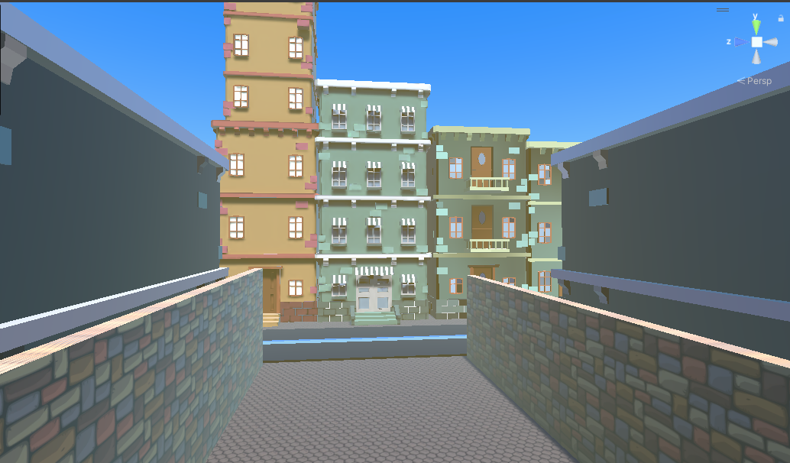

Runner

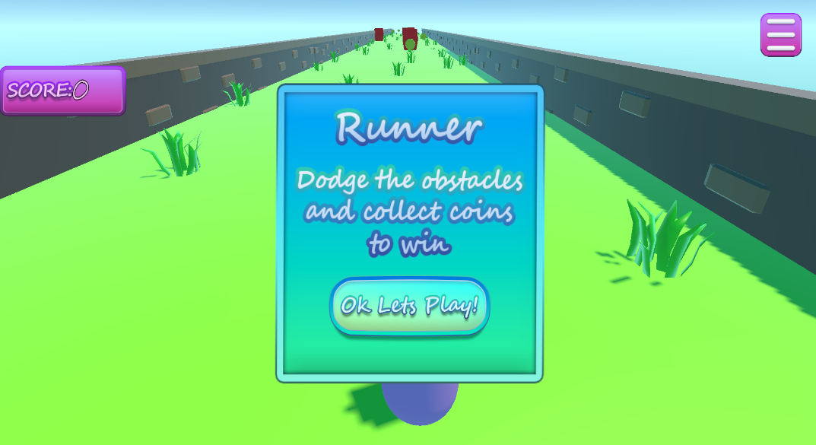

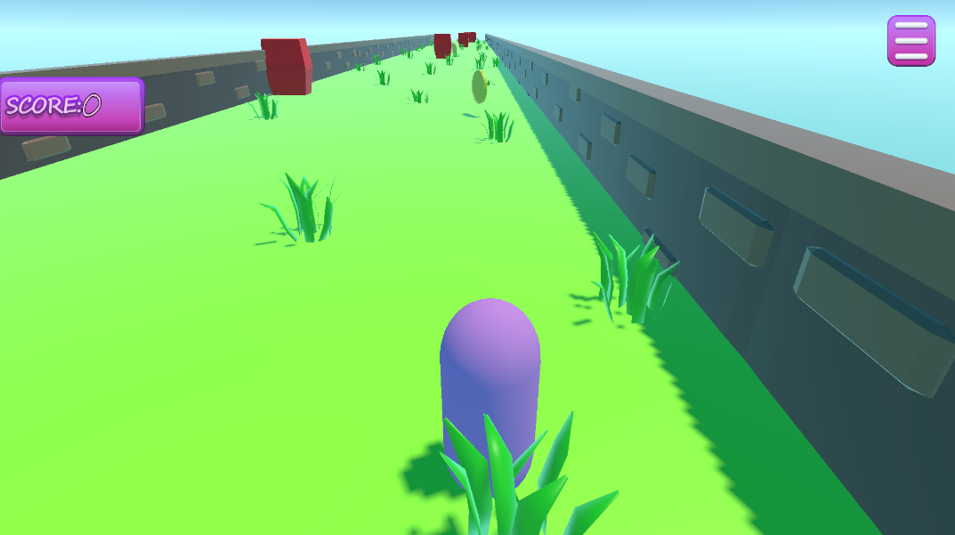

Maze

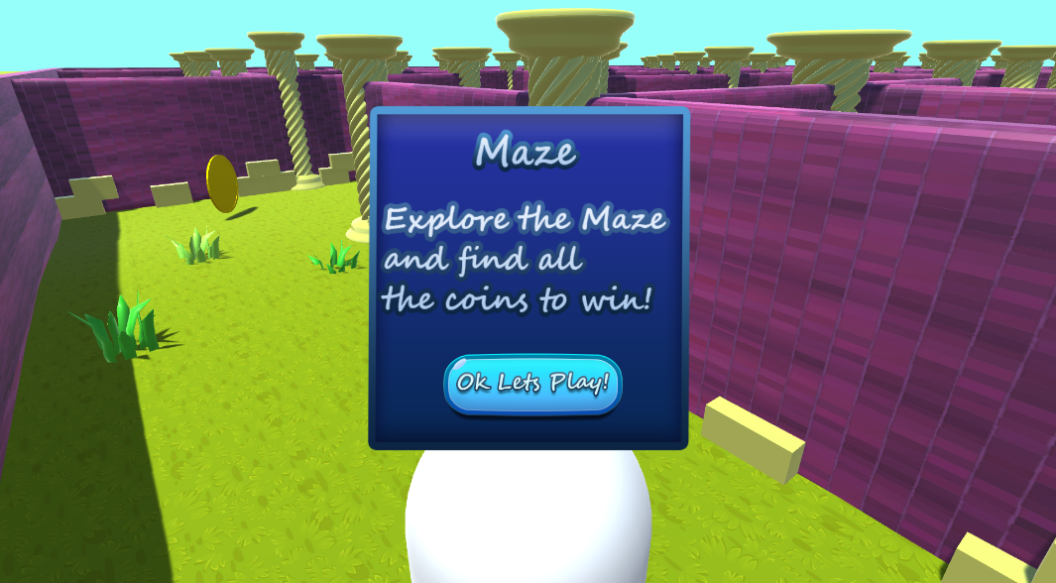

**UI**

Process:

The initial idea for the UI was to have it static so that it would be easier to lay out all the UI placement and Unity Panel settings.

The UI production started when I decided to create all my own assets in photoshop.

After some experimenting in Photoshop I decided the style I wanted the UI to be and made various different Panels and Buttons to use in the game. The general UI style I decided to go for was bubbly and bright so it stands out to the player. I then proceeded to learn more about the different features and tools within Photoshop I could use to make the UI even better.

After creating the Assets and linking them to all the relevant parts , the Canvas was divided into various panels

**Hurdles**

Code Problems:

One of the first initial code problems I had was the Timescale in Unity was not being set properly and the game would freeze whenever the scene changed, after some debugging the problem turned out to be that the timescale was being set to 0 in a separate script.

Time Constraints

Lighting

**Further Research**

**Future Development**

Other minigames

More features

**Conclusion**

**REFERENCES:**

**Textures and Images:**

Menu Brick

<https://www.freepik.com/free-vector/colorful-brick-wall-texture_957410.htm#query=cartoon%20brick%20texture&position=0&from_view=keyword&track=ais&uuid=758e403a-3886-4f9e-a55c-1ad2c9029686>

Menu Stone Ground:

<https://www.freepik.com/free-vector/cartoon-style-stone-texture_1076785.htm#query=cartoon%20concrete%20texture&position=3&from_view=search&track=ais&uuid=b786bc96-863a-4357-992b-b75faa657160>

Maze Wall:

<https://www.freepik.com/free-vector/bricks-wall-background_894094.htm#query=cartoon%20wall%20texture&position=36&from_view=search&track=ais&uuid=649be548-2088-4653-bd4d-5d9da2b18d9d>

Maze Grass:

[https://www.freepik.com/free-vector/seamless-textured-grass-natural-grass-pattern_11930799.htm#query=cartoon%20grass%20texture&position=0&from_view=keyword&track=ais&uuid=12a73418-a761-4592-bbcc-7d4b4ef3f2f8#position=0&query=cartoon%20grass%20texture](https://www.freepik.com/free-vector/seamless-textured-grass-natural-grass-pattern_11930799.htm#position=0&query=cartoon%20grass%20texture)

**Models:**

<https://quaternius.com/packs/animatedwomen.html>

<https://quaternius.com/packs/ultimatefurniture.html>